# 5.1-Test Planning

5-1-CH5 Part1 - start at 2:16

## 5.1.1-Purpose and Content of a Test Plan

5-1-CH5 Part1 - start at 2:16

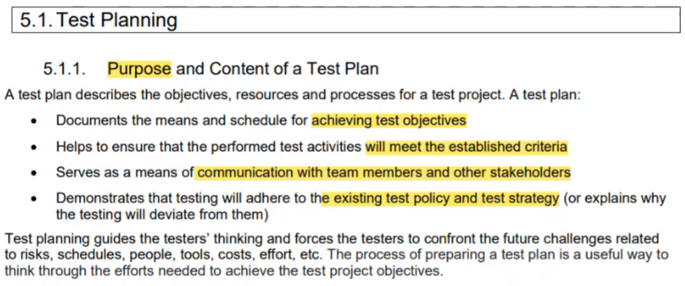

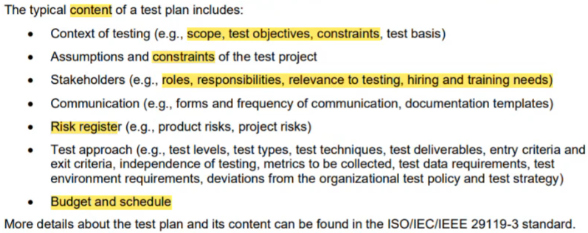

## 5.1.2-Tester's Contribution to Iteration and Release Planning

5-1-CH5 Part1 - start at 11:11

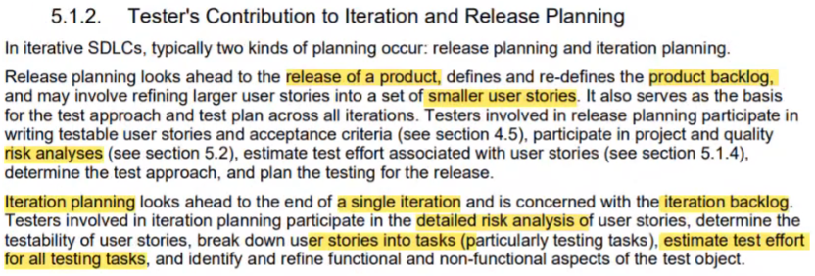

## 5.1.3- Entry Criteria and Exit Criteria

5-1-CH5 Part1 - start at 15:46

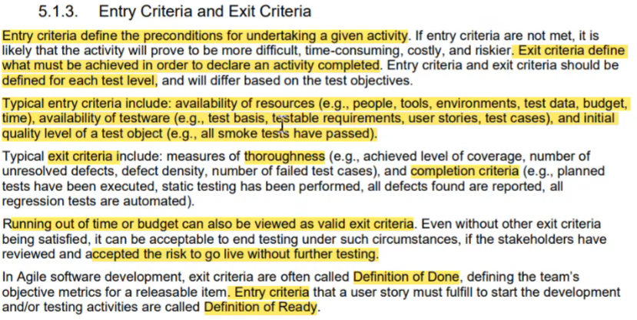

## 5.1.4-Estimation Techniques

5-1-CH5 Part1 - start at 23:25

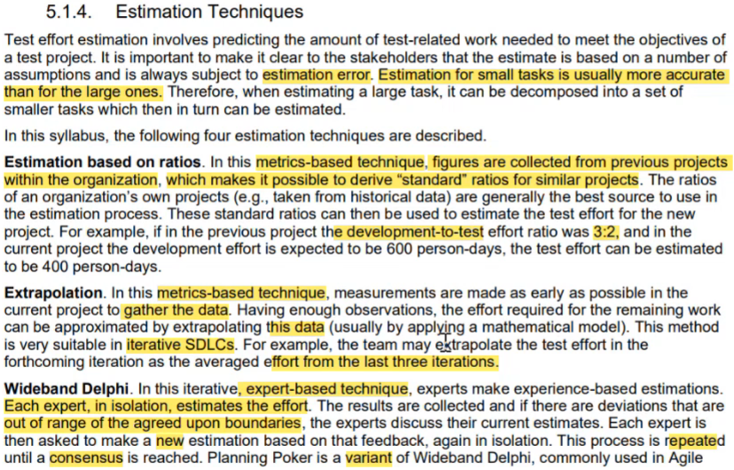

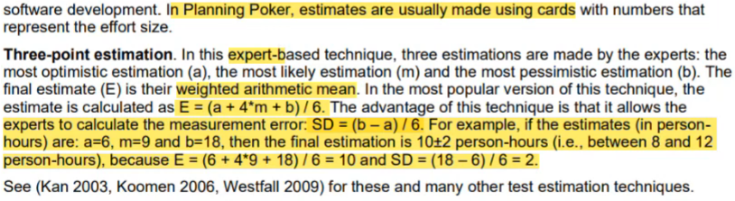

## 5.1.5-Test Case Prioritization

5-1-CH5 Part1 - start at 38:05

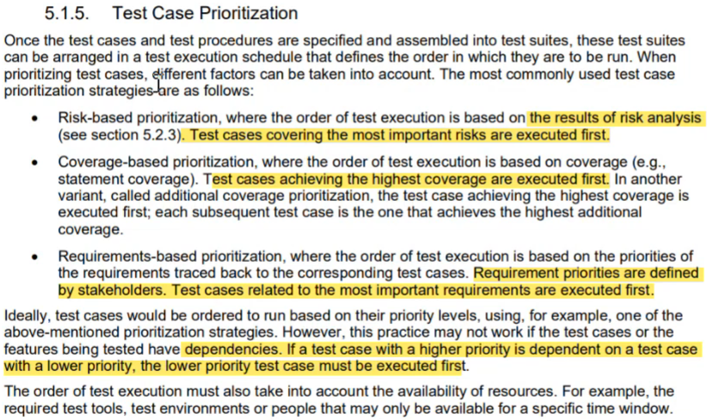

## 5.1.6- Test Pyramid

5-1-CH5 Part1 - start at 42:28

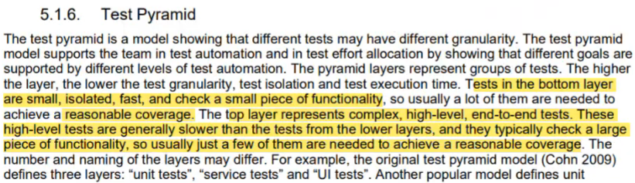



## 5.1.7- Testing Quadrants

5-1-CH5 Part1 - start at 44:10

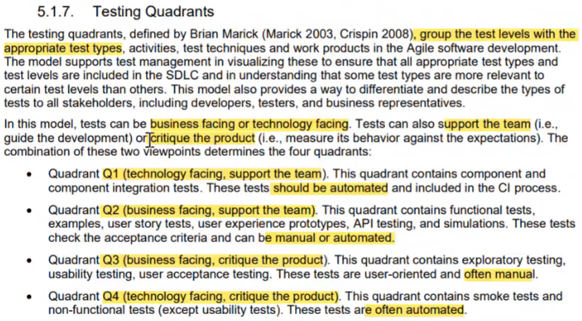

### Testing Quadrants Summary

5-1-CH5 Part1 - start at 52:00

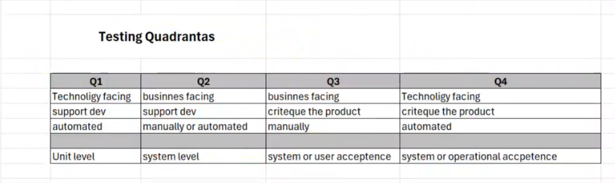

# 5.2-Risk Management

5-2-CH5 part2 _ CH6 - start at 0:09

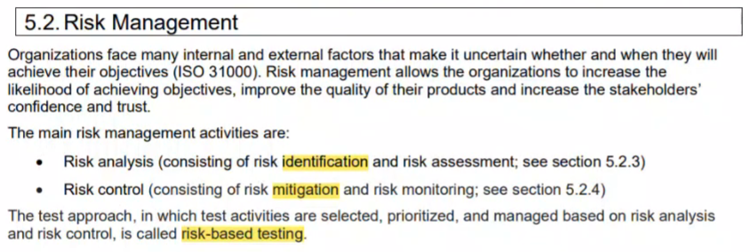

5-2-CH5 part2 _ CH6 - start at 0:09

## 5.2.1-Risk Definition and Risk Attributes

5-2-CH5 part2 _ CH6 - start at 0:09

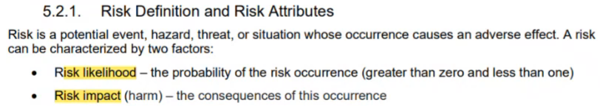



## 5.2.2-Product Risk Analysis

5-2-CH5 part2 _ CH6 - start at 2:21

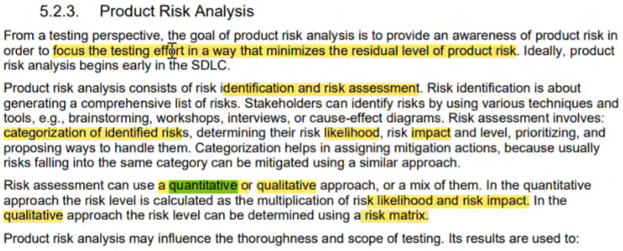

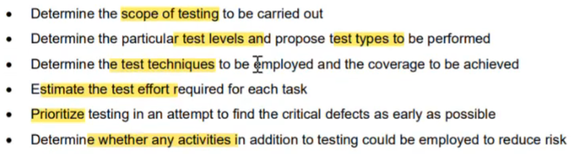

## 5.2.3-Project Risks and Product Risks

5-2-CH5 part2 _ CH6 - start at 3:59

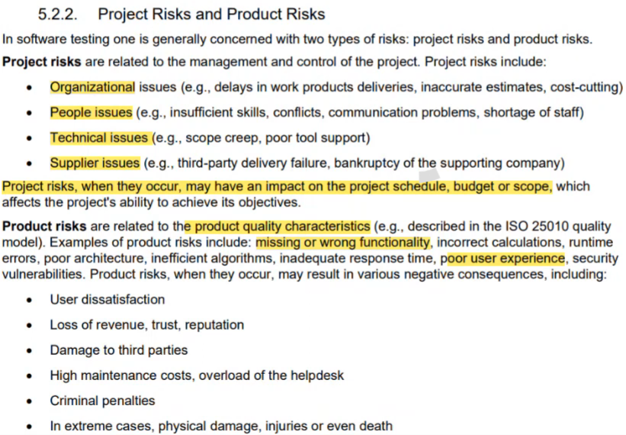

## 5.2.4-Product Risk Control

5-2-CH5 part2 _ CH6 - start at 13:12

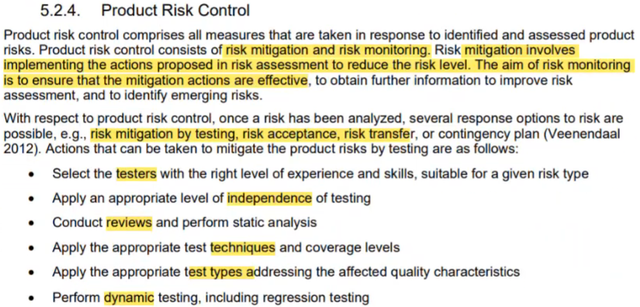

# 5.3- Test Monitoring, Test Control and Test Completion

5-2-CH5 part2 _ CH6 - start at 17:29

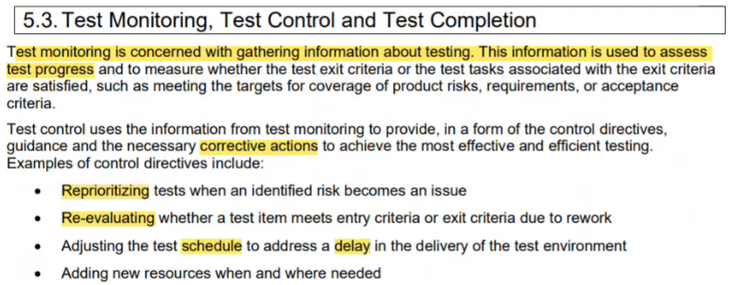

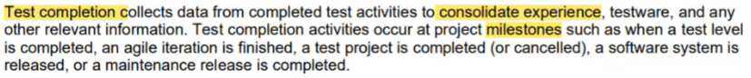

## 5.3.1- Metrics used in Testing

5-2-CH5 part2 _ CH6 - start at 21:05

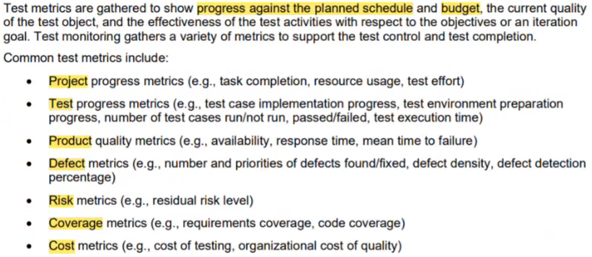

## 5.3.2- Purpose, Content and Audience for Test Reports

5-2-CH5 part2 _ CH6 - start at 28:05

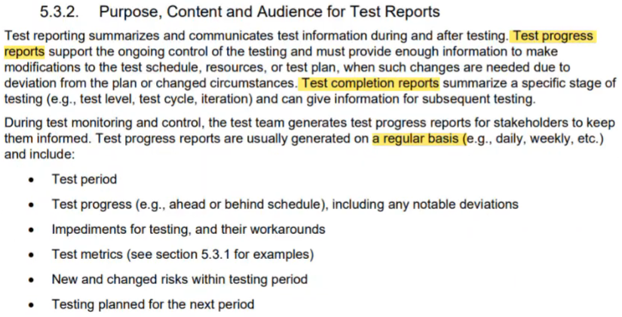

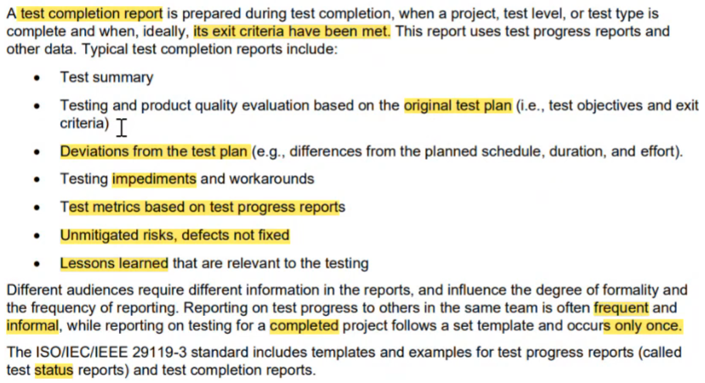

## 5.3.3- Communicating the Status of Testing

5-2-CH5 part2 _ CH6 - start at 34:30

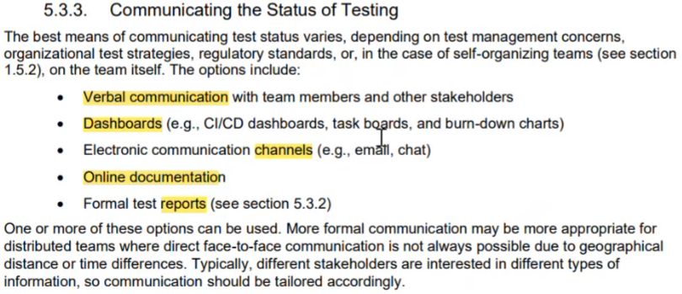

# 5.4-Configuration Management

5-2-CH5 part2 _ CH6 - start at 35:47

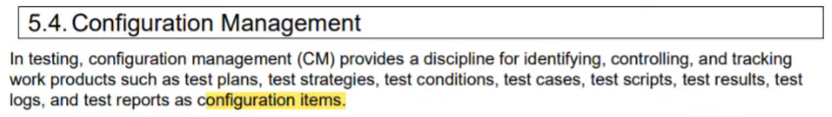

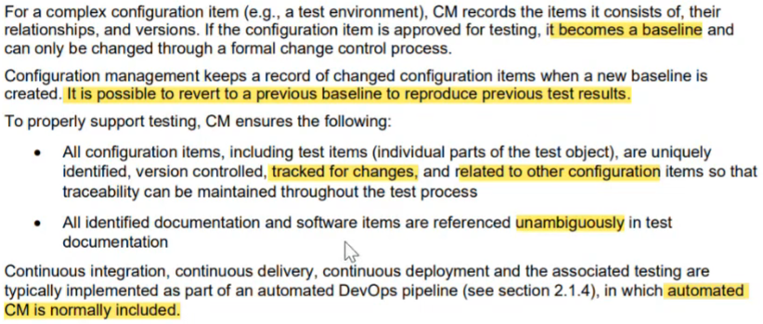

# 5.5- Defect Management

5-2-CH5 part2 _ CH6 - start at 39:23

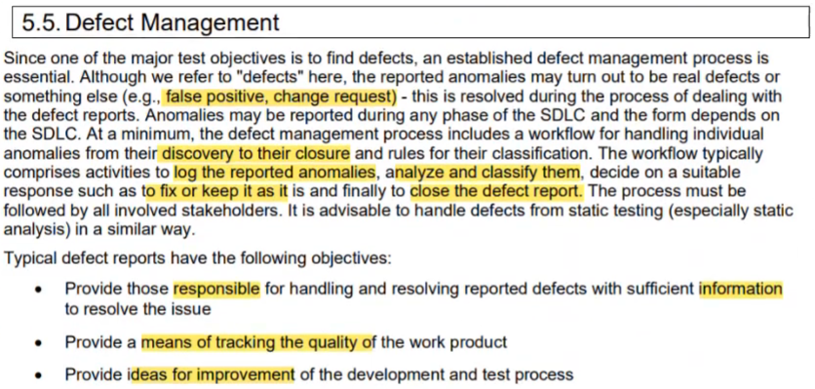

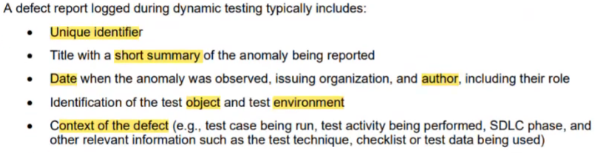

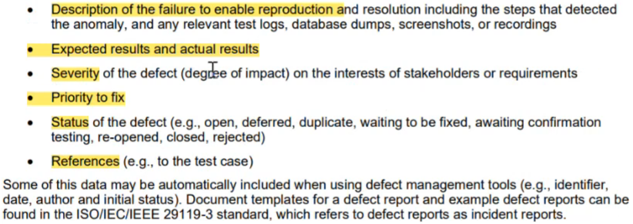

# 6.1-Tool Support for Testing

5-2-CH5 part2 _ CH6 - start at 48:02

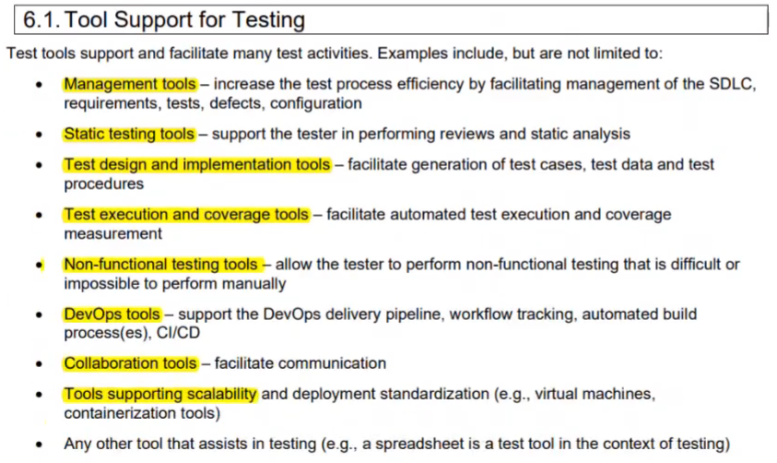

# 6.2-Benefits and Risks of Test Automation

5-2-CH5 part2 _ CH6 - start at 50:35

